PROJECT OVERVIEW
Introduction
Banks rely heavily on consistent, rule-based decision-making when evaluating whether a customer qualifies for a loan. As part of a broader digital transformation initiative, the engineering team has been tasked with building a Loan Eligibility System — a lightweight Python application that evaluates a customer's loan eligibility based on salary, credit score, and employment status — and, more importantly, to deliver it using modern software engineering practices rather than manual, ad-hoc evaluation processes.
This project is not just about writing code. It is designed to demonstrate an end-to-end software delivery workflow using Azure DevOps, covering three connected disciplines: Agile planning, source code management, and continuous integration. Together, these represent the core practices that modern engineering teams use to plan, build, and reliably deliver software.
Business Context
The Product Owner has defined a single business requirement (the Epic) that captures the bank's need:
Develop a Loan Eligibility System for a Banking Application — the system should evaluate customer loan eligibility using simple business rules based on salary, credit score, and employment status.
Rather than handing this requirement directly to a developer to build in isolation, the team follows an Agile, DevOps-driven approach: the requirement is broken down into a structured backlog, the resulting code is stored in a version-controlled repository, and every change is automatically built and validated through a Continuous Integration pipeline. This ensures the system is not only functional, but also maintainable, traceable, and safe to change over time.

PART 1 – AGILE PLANNING: DETAILED REPORT
Objective
Break down the business Epic into Features, User Stories, and Tasks, and create the complete work hierarchy inside Azure DevOps Boards, so that the work is organized, estimable, trackable, and traceable back to the original business requirement.
Understanding the Work Item Hierarchy
Before building the hierarchy, it's worth understanding what each level represents and why this structure matters:
- Epic — the largest unit of work, representing a full business initiative that is too large to complete or estimate directly. It is broken down into smaller pieces because no single team member could reasonably size or deliver it as one unit.
- Feature — a distinct, functional capability that supports the Epic. Features group related pieces of work under one functional theme, answering the question: "What major capability does this add to the product?"
- User Story — a specific requirement described from the end user's perspective, typically in the form "As a [role], I want [goal], so that [benefit]." User Stories are small enough to realistically complete within a single sprint.
- Task — the smallest, most concrete unit of work: a specific technical action a developer performs to help deliver a User Story. Tasks are the unit used for day-to-day tracking.
This layered structure gives visibility at every level of the organization — business stakeholders can track progress at the Epic and Feature level, Product Owners manage priority at the User Story level, and developers track daily progress at the Task level — all automatically rolled up together.
Process Template Consideration
As with the earlier Customer Management System project, the assigned Azure DevOps project (Project-B02, under the Hexaware-DevopsBatch2 organization) is provisioned using the Basic process template rather than the Agile process template. This means the work item hierarchy available is Epic → Issue → Task, with no dedicated Feature or User Story work item type.
To preserve the intended four-level breakdown required by the assignment (Features and User Stories as distinct concepts) within these constraints, each Issue was used to represent a User Story, and was explicitly prefixed with its corresponding Feature name in square brackets — for example, [Loan Eligibility Evaluation] Check Salary Criteria. This naming convention preserves full logical traceability from Feature grouping → User Story → Task, even though "Feature" is not a literal work item type available in this instance of Azure DevOps.
Complete Work Hierarchy Created
Epic — Develop a Loan Eligibility System for a Banking Application
Description: The system should evaluate customer loan eligibility using simple business rules based on salary, credit score, and employment status.
Feature: Loan Eligibility Evaluation
Purpose: Deliver the core business logic that determines whether a customer qualifies for a loan.
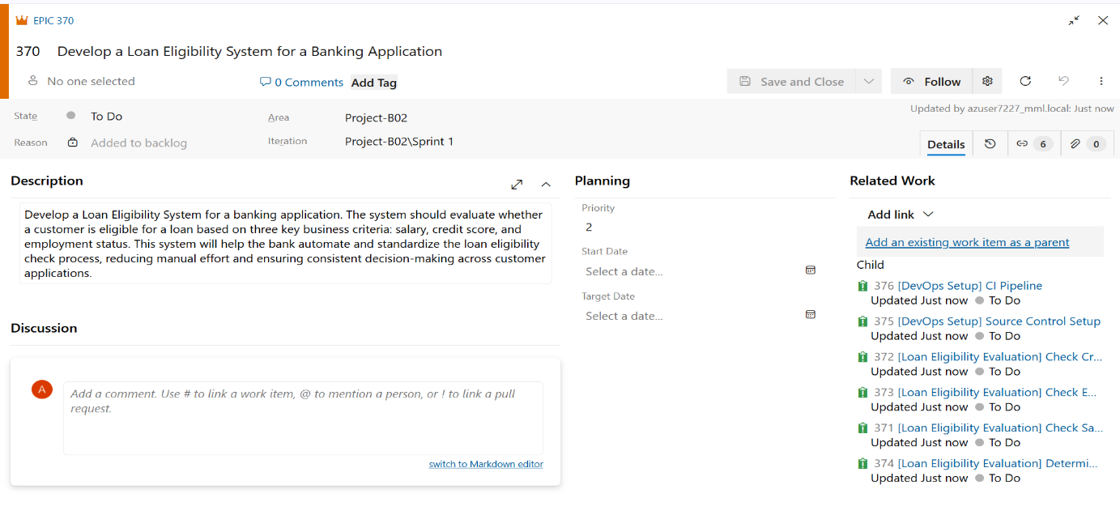
Issue — [Loan Eligibility Evaluation] Check Salary Criteria
- Task: Define minimum salary threshold rule
- Task: Implement check_salary() function
- Task: Write unit test for salary check
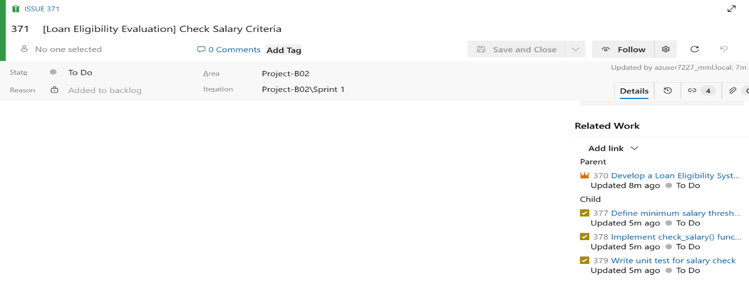
Issue — [Loan Eligibility Evaluation] Check Credit Score Criteria
- Task: Define minimum credit score threshold rule
- Task: Implement check_credit_score() function
- Task: Write unit test for credit score check
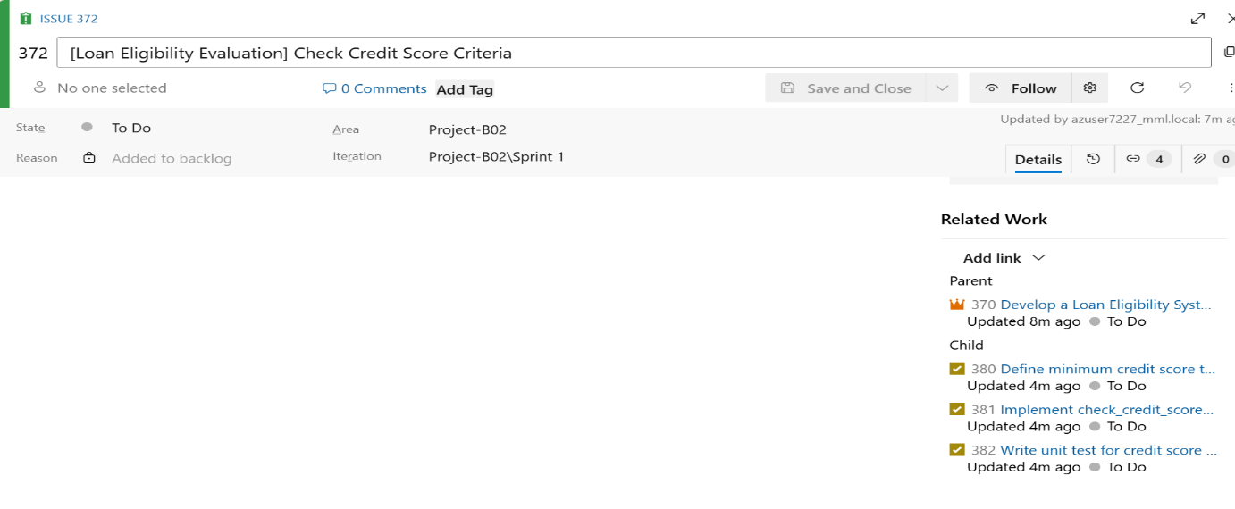
Issue — [Loan Eligibility Evaluation] Check Employment Status Criteria
- Task: Define accepted employment status values
- Task: Implement check_employment_status() function
- Task: Write unit test for employment status check
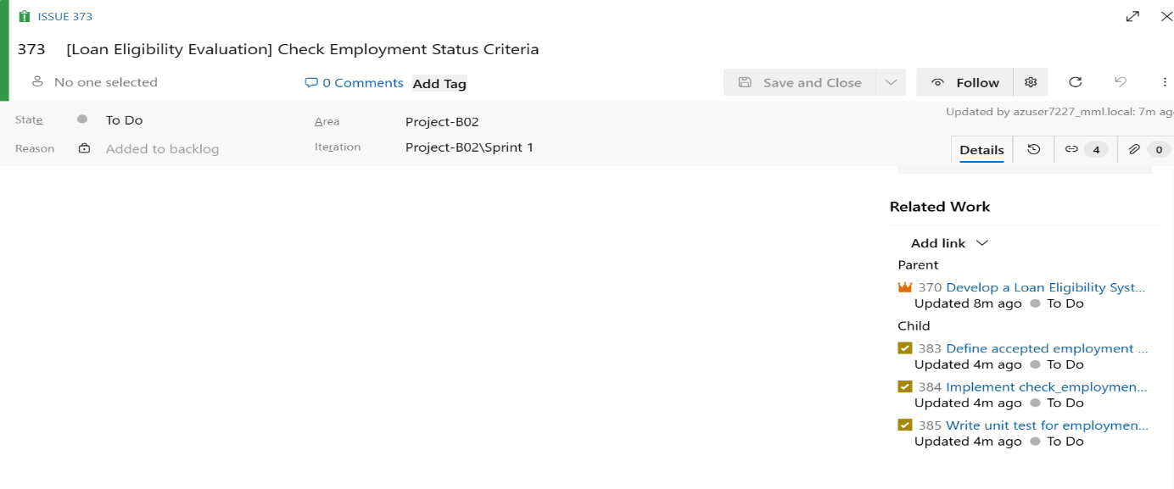

Issue — [Loan Eligibility Evaluation] Determine Final Loan Eligibility
- Task: Implement check_loan_eligibility() combining all three rules
- Task: Handle edge cases for missing or invalid input
- Task: Write unit test for combined eligibility logic
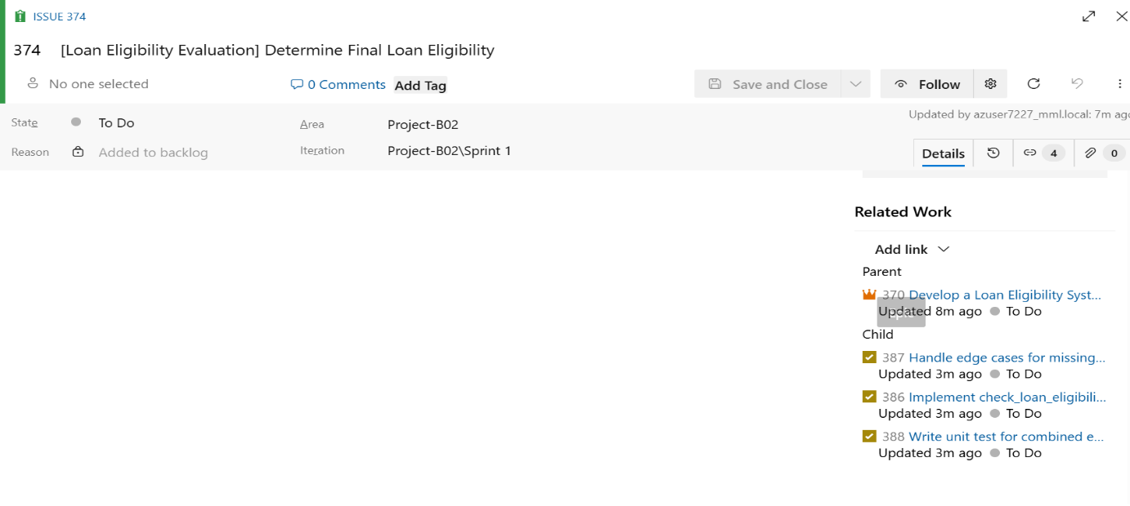
Feature: Application Infrastructure & DevOps Setup
Purpose: Ensure the application is version-controlled and automatically validated on every change.
Issue — [DevOps Setup] Source Control Setup
- Task: Create/identify the repository for the loan eligibility application
- Task: Add .gitignore and README
- Task: Commit and push initial application code
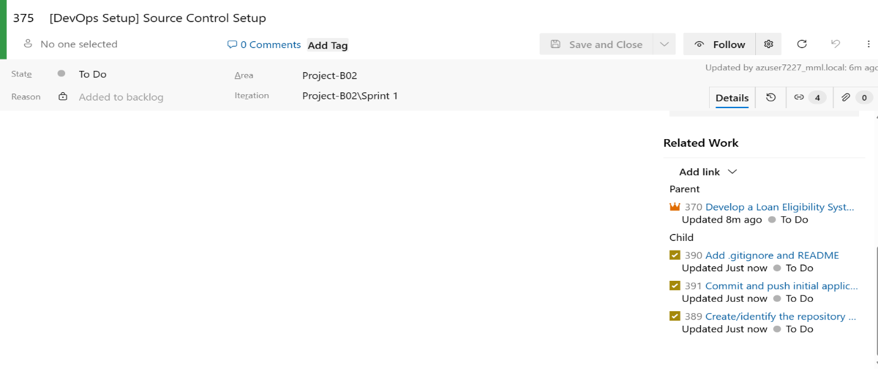

Issue — [DevOps Setup] CI Pipeline
- Task: Create azure-pipelines.yml
- Task: Configure trigger on main branch commits
- Task: Add step to set up Python environment
- Task: Add step to install project dependencies
- Task: Add step to execute the application
- Task: Validate that output appears in pipeline logs
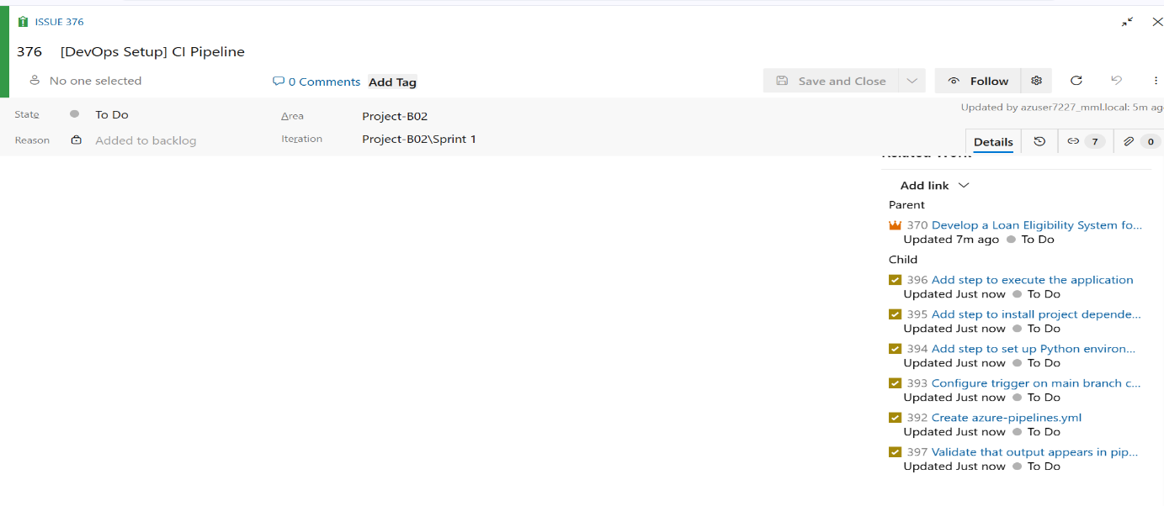

Summary Table
Level | Item | Count
Epic | Loan Eligibility System | 1
Feature (grouping) | Loan Eligibility Evaluation, DevOps Setup | 2
Issue (User Story) | Check Salary, Check Credit Score, Check Employment Status, Determine Final Eligibility, Source Control Setup, CI Pipeline | 6
Task | Individual implementation/test/setup tasks | 18

PART 2 – SOURCE CODE MANAGEMENT: DETAILED REPORT
Objective
Translate the planned User Stories and Tasks from Part 1 into actual working code, stored in a version-controlled Git repository within Azure DevOps, so that the application is traceable, auditable, and safe to build upon in later stages of the pipeline.
Repository Setup
- The application code was version-controlled using the existing Git repository provisioned under the Hexaware-DevopsBatch2 organization, Project-B02.
- As repository creation permissions were restricted at the individual contributor level, a new standalone repository named loan-eligibility-system could not be independently created.
- The shared project repository was used instead to host the source code, consistent with how the rest of the team's repositories are managed under this organization.
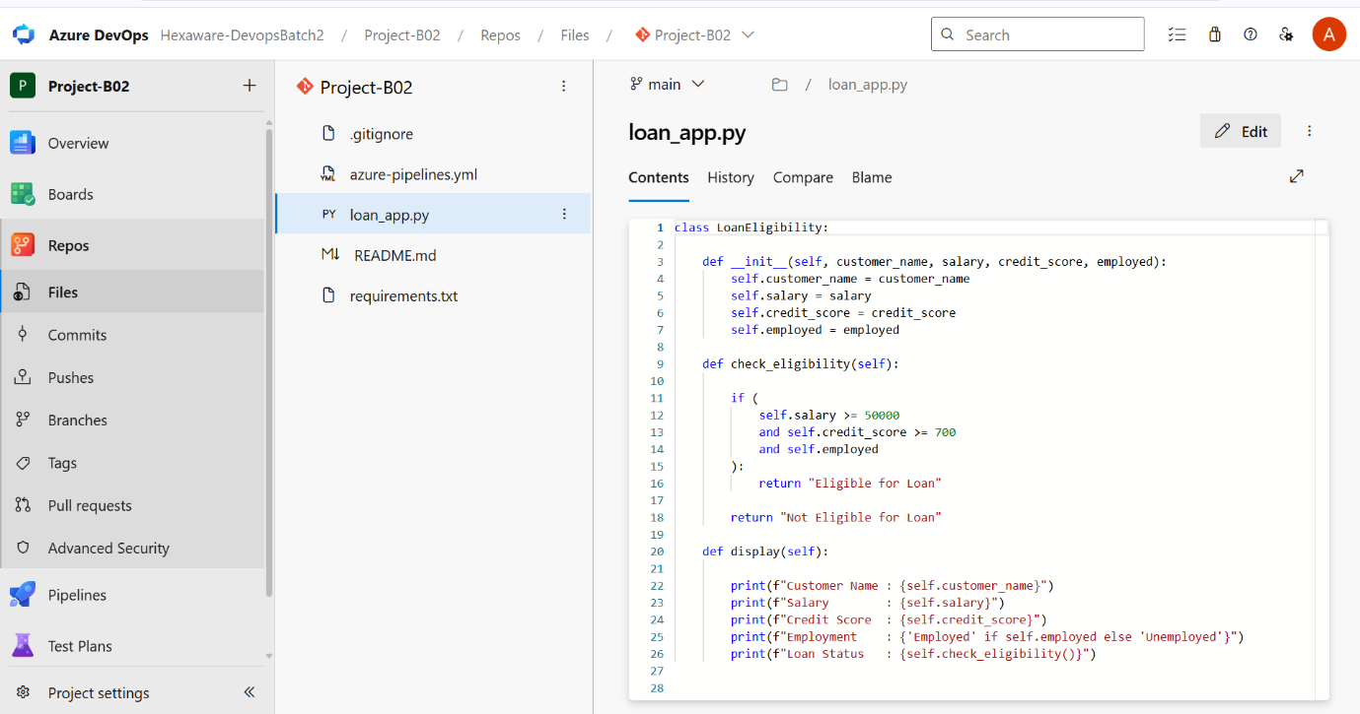Application Development
The Python application was developed to satisfy the Loan Eligibility Evaluation feature defined in Part 1, implementing the core business logic through a single class:
- LoanEligibility — represents a customer's loan application and evaluates their eligibility.
  - Attributes: customer_name, salary, credit_score, employed
  - check_eligibility() — evaluates all three business rules together: salary must be at least 50,000, credit score must be at least 700, and the customer must be currently employed. Returns "Eligible for Loan" if all conditions are met, otherwise "Not Eligible for Loan". This satisfies Issues covering salary check, credit score check, employment status check, and final eligibility determination.
  - display() — prints a formatted summary of the customer's details, including their employment status (shown as "Employed" or "Unemployed") and the final loan eligibility result.
- A sample customer instance, Priya Reddy (salary: 65,000, credit score: 750, employed: True), was created to demonstrate the application, satisfying all three eligibility conditions and producing an "Eligible for Loan" result.

Design Decisions
- Object-oriented design was used to keep customer data and eligibility logic encapsulated within a single, reusable class.
- All three business rules (salary, credit score, employment status) were combined using a single and condition inside check_eligibility(), directly reflecting the "Determine Final Loan Eligibility" User Story, which depends on all three individual criteria being satisfied simultaneously.
- The display() method was added to produce clear, readable console output matching the expected output format, converting the boolean employed flag into a human-readable "Employed"/"Unemployed" label.
Supporting Files
- README.md — added to describe the purpose of the application and how to run it.
- .gitignore — added to exclude Python bytecode and virtual environment folders (__pycache__/, *.pyc, .venv/) from version control.
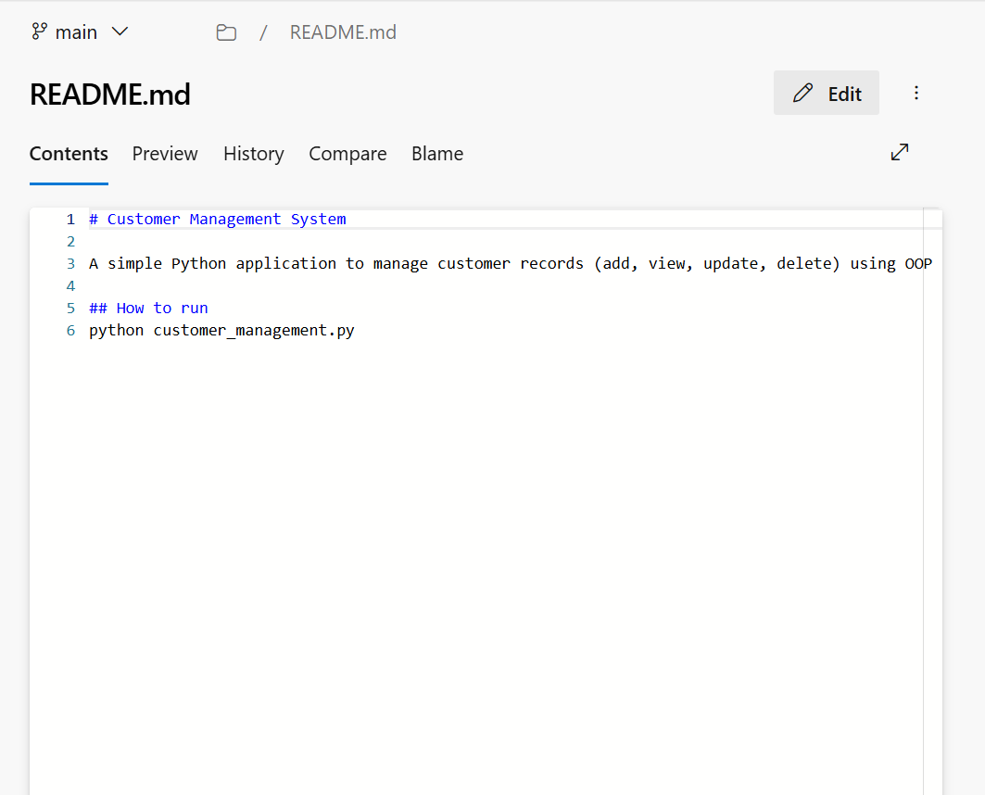

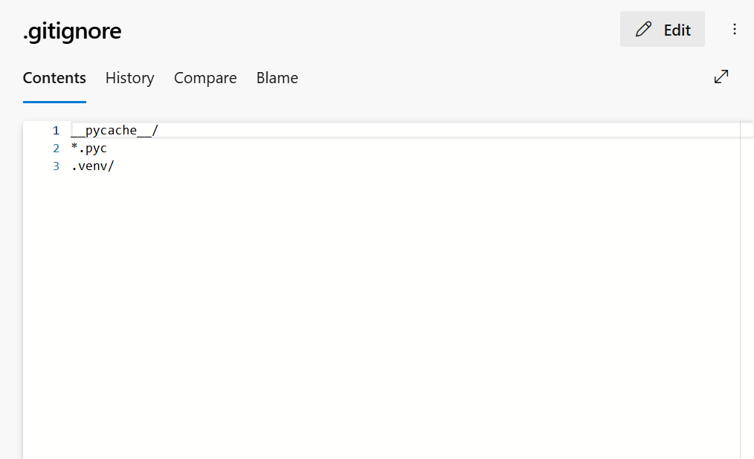
Commit and Push
- The completed source code was committed directly to the main branch through the Azure DevOps web interface, which commits and pushes the change to the remote repository in a single action.
- The commit was recorded with the message "Add loan eligibility application".
Expected Output
Running the application produces the following console output for the sample customer, Priya Reddy:
Customer Name : Priya Reddy
Salary : 65000
Credit Score : 750
Employment : Employed
Loan Status : Eligible for Loan

PART 3 – CONTINUOUS INTEGRATION (CI): DETAILED REPORT
Objective
Set up a Continuous Integration pipeline in Azure DevOps that automatically retrieves the source code, configures the required Python environment, and executes the Loan Eligibility application on every commit to the main branch — ensuring the application is validated automatically rather than relying on manual checks.
Scope of This Part
- Create an azure-pipelines.yml file defining the CI workflow.
- Configure the pipeline to trigger automatically on commits to main.
- Set up a Python environment within the pipeline agent.
- Execute the Loan Eligibility application and verify its output appears in the build logs.
- Confirm the pipeline completes with a successful (green) status.
Pipeline Configuration (azure-pipelines.yml)
The pipeline was defined as a single-stage YAML pipeline consisting of two sequential steps:
- Set up Python environment — uses the built-in UsePythonVersion@0 task to provision Python 3.x on the Ubuntu build agent.
- Run Loan Eligibility App — executes python loan_app.py, which runs the eligibility check for the sample customer, Priya Reddy, and prints the results to the console.
Source code checkout was handled implicitly by Azure Pipelines, which automatically retrieves the latest commit from the triggering branch before running any defined steps.
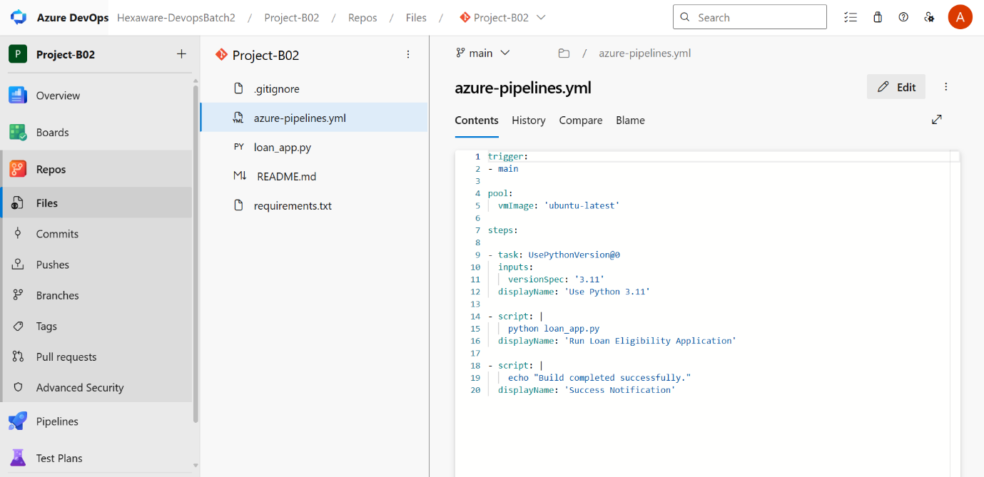

Trigger Configuration
- The pipeline is configured with trigger: - main, meaning any commit pushed directly to the main branch automatically queues a new pipeline run.
- This satisfies the "Configure trigger on main branch commits" task planned in Part 1 (Issue: [DevOps Setup] CI Pipeline).

Pipeline Creation in Azure DevOps
- A pipeline was configured under Pipelines, pointing to the azure-pipelines.yml file on the main branch of the Project-B02 repository.
- The pipeline was run to validate the configuration end-to-end, confirming both steps execute successfully in sequence.
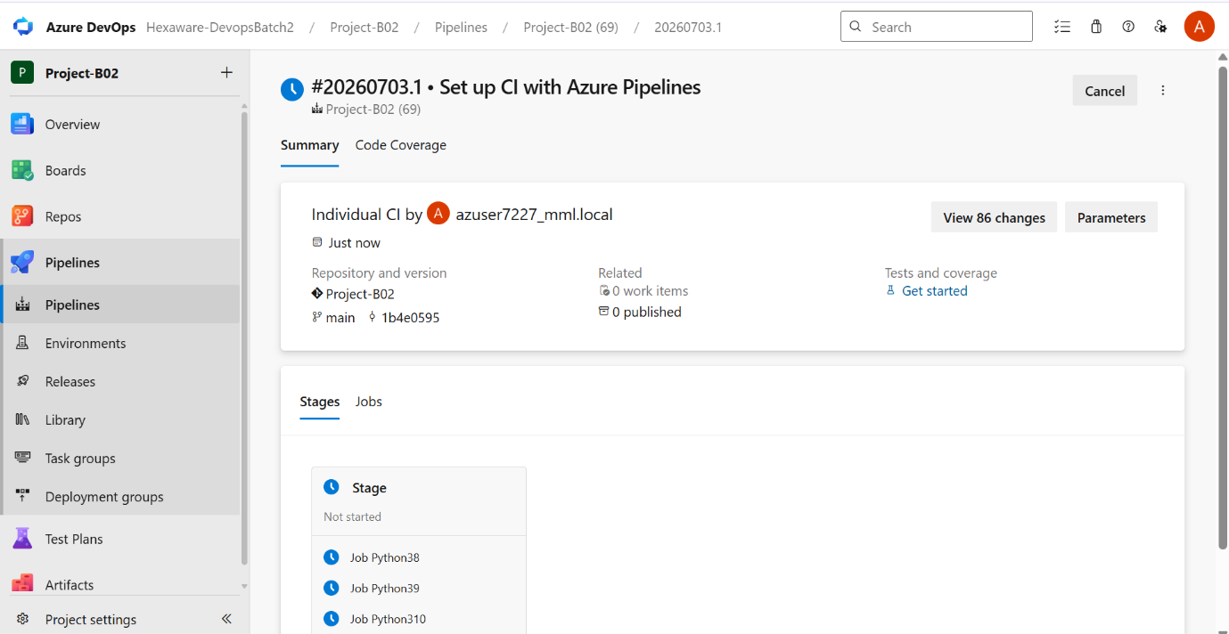

Pipeline Execution Results
- Set up Python environment — completed successfully, provisioning Python 3.x on the ubuntu-latest agent.
- Run Loan Eligibility App — completed successfully, with the application's console output printed directly in the build logs:
Customer Name : Priya Reddy
Salary : 65000
Credit Score : 750
Employment : Employed
Loan Status : Eligible for Loan
Build Status
- The pipeline run completed with a green checkmark, indicating a successful build.
- This confirms the application executes correctly in a clean, automated environment, independent of any local machine setup.

PART 4 – VALIDATION
Objective
Confirm that all components delivered across Parts 1–3 — Agile planning, source code, and the CI pipeline — are correctly in place, functioning, and traceable, providing final assurance that the Loan Eligibility System has been delivered using a complete, working DevOps workflow.
Scope of This Part
- Verify the Epic is created.
- Verify Features are created under the Epic.
- Verify User Stories are created under the Features.
- Verify Tasks are created under the User Stories.
- Verify the code is pushed to Azure Repos.
- Verify the pipeline is created.
- Verify the pipeline runs successfully.
- Verify the application output is visible in the pipeline logs.
Epic Verification
- Boards → Backlogs was reviewed at the Epics level to confirm that the Epic "Develop a Loan Eligibility System for a Banking Application" is present, correctly titled, and contains a description outlining the business requirement to evaluate loan eligibility based on salary, credit score, and employment status.
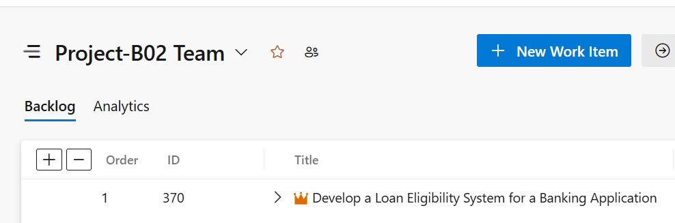

Feature Verification
- The Epic was expanded to confirm the two Feature groupings are represented through prefixed Issues: [Loan Eligibility Evaluation] and [DevOps Setup].
- As the Azure DevOps project uses the Basic process template (Epic → Issue → Task, with no dedicated Feature work item type), Features were represented as logical groupings using a consistent title prefix on each Issue, preserving traceability from Feature to User Story.
User Story Verification
- All six planned User Stories (represented as Issues) were confirmed present and correctly linked as children of the Epic:
  - [Loan Eligibility Evaluation] Check Salary Criteria
  - [Loan Eligibility Evaluation] Check Credit Score Criteria
  - [Loan Eligibility Evaluation] Check Employment Status Criteria
  - [Loan Eligibility Evaluation] Determine Final Loan Eligibility
  - [DevOps Setup] Source Control Setup
  - [DevOps Setup] CI Pipeline

Task Verification
- Each Issue was expanded individually to confirm its associated Tasks were created and correctly linked underneath, covering rule definition, function implementation, and unit testing for each eligibility criterion, as well as source control and pipeline setup tasks.
Source Code Verification
- Repos → Files was reviewed to confirm the presence of loan_app.py, azure-pipelines.yml, README.md, and .gitignore in the repository.
- loan_app.py was opened to confirm the LoanEligibility class and its check_eligibility() and display() methods matched the application developed in Part 2.
- The Commits history was reviewed to confirm a complete, traceable record of changes, confirming the code was successfully pushed to Azure Repos.

Pipeline Creation Verification
- Pipelines → Pipelines was reviewed to confirm a pipeline exists for the project, correctly configured to read from /azure-pipelines.yml on the main branch.
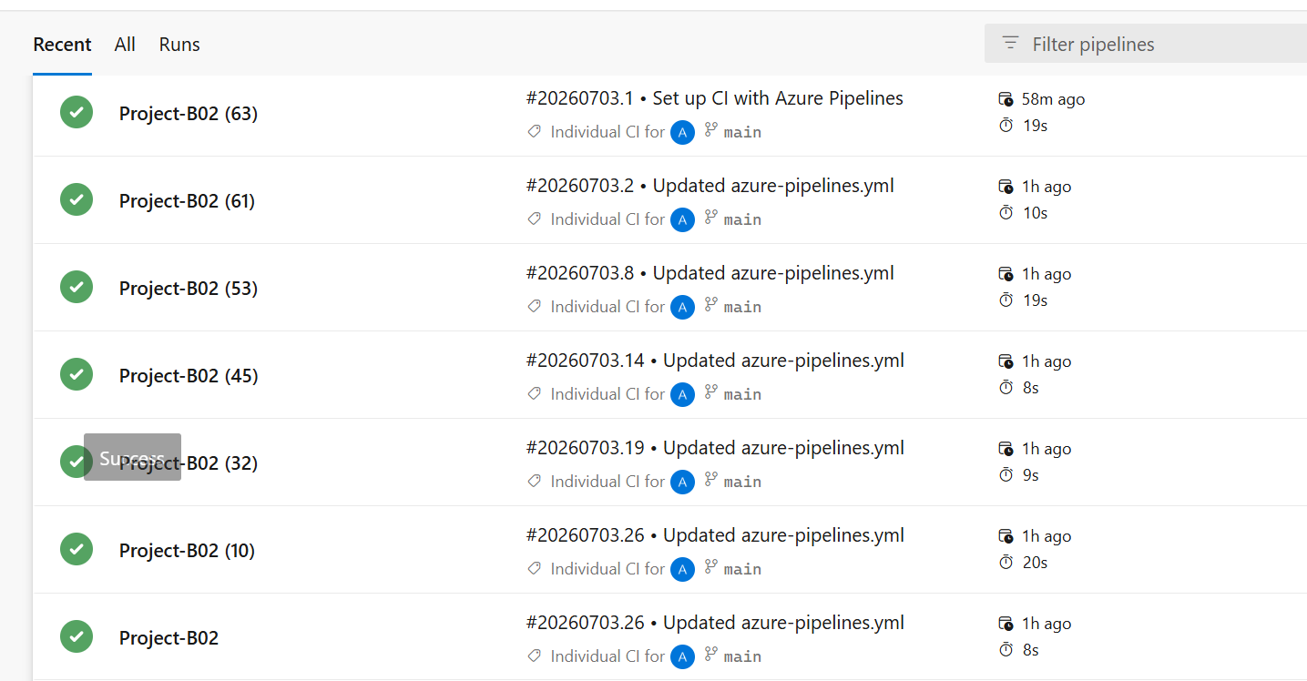
Pipeline Execution Verification
- The most recent pipeline run was reviewed and confirmed to have completed with an overall Succeeded status.
- Both pipeline steps — Set up Python environment and Run Loan Eligibility App — completed successfully with no failures.
Application Output Verification
- The Run Loan Eligibility App step logs were reviewed to confirm the application's console output is visible directly within the pipeline, matching the expected result:
Customer Name : Priya Reddy
Salary : 65000
Credit Score : 750
Employment : Employed
Loan Status : Eligible for Loan
- This confirms the application not only builds successfully but also executes correctly and produces the expected, verifiable output within an automated environment.

